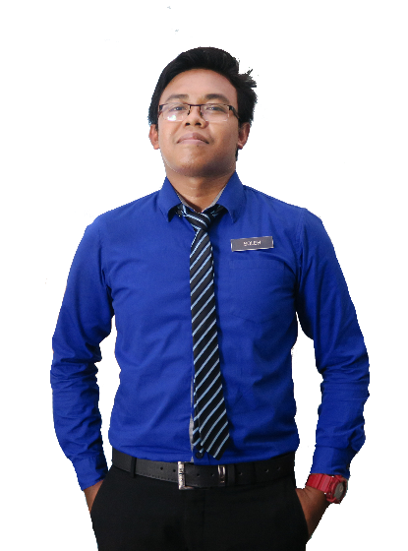

TEACHER & GRAPHIC DESIGNER

# Creative

PERSONAL SKILLS

# Friendliness

# Communication

# Leadership

# Teamwork

SKILLS

# Microsoft Office

# Adobe Photoshop

# Adobe Photoshop

# Microsoft Office

ACHIEVEMENT

* Graphic Design Award 2015, Kuala Lumpur
* Anugerah Guru Cemerlang SMK Bandar Baru Sungai Buloh 2016
* Larian Hari Sukan Negara 2016, UiTM Kampus Puncak Alam
* Volunteer for SUKMA 18, Pahang Darul Makmur
* Creative and Innovation Awards 2017
* Anugerah Perkhidmatan Cemerlang Daerah Gombak
* Pengurusi Kelab Rakan Muda Daerah Gombak 2014
* Setiausaha Persatuan Perguruan Daerah Temerloh
* Exco Multimedia Majlis Perwakilan Pelajar UiTM 2015

**SEKOLAH MEN KEB BANDAR BARU SUNGAI BULOH**

Teacher

Implements curriculum objectives and goals using effective teaching techniques and materials. Develops, in a cooperative manner with the principal and curriculum facilitators, a plan for the improvement and enrichment of instruction.

**2014 - 2016**

Teach at undergraduate and graduate level in areas allocated by the Head of Department and reviewed from time to time by the Head of Department. Carry out research and produce publications, or other research outputs, in line with personal objectives agreed in the Staff review process.

Teacher

**2014 - 2016**

Implements curriculum objectives and goals using effective teaching techniques and materials. Develops, in a cooperative manner with the principal and curriculum facilitators, a plan for the improvement and enrichment of instruction.

**SEKOLAH MEN KEB BANDAR BARU SUNGAI BULOH**

**KOLEJ MATRIKULASI KEDAH, CHANGLUN**

Science Stream (Module II)

**2014 - 2016**

**SEKOLAH MENENGAH KEBANSAAN FELDA JELAI**

Sijil Pelajaran Malaysia (SPM)

**2014 - 2016**

**UNIVERSITI TEKNOLOGI MARA, KAMPUS PUNCAK ALAM**

Bachelor of Education in Science (Hons) Chemistry

**2014 - 2016**

Master in Science

EDUCATION

**UNIVERSITI TEKNOLOGI MARA SHAH ALAM**

**2014 - 2016**

Academic Advisor,

Fakulti Pendidikan,

Universiti Teknologi Mara,

Kampus Puncak Alam, Selangor

Email: [furkan@uitm.edu.my](mailto:furkan@uitm.edu.my)

Phone: +6013-2805916

**FURKAN BIN MAT SALLEH**

REFERENCES

Address:

Creative Resume, 74000 Bandar Puncak Alam, Selangor

Phone:

+6013-2805916

Email:

resumecreative@yahoo.com

CONTACT ME

**2014 - 2016**

EXPERIENCE

**UNIVERSITI TEKNOLOGI MARA, KAMPUS PUNCAK ALAM**

Lecturer

As a future educator, I will be creating knowledgeable leaders who have the ability to take their own decisions and rise with their community. I believe to be a great teacher, connections need to be made with students’, support needs to be given and passionate teaching should be seen through the student eyes.

**MUHD** SOLEH